- . To Apply Double Quotes, Preserve Spaces, Allow Variable Expansion, Parse Nested Tokens, Validate Outputs, Test Quoted Commands

Aim : To implement double quotes in a shell parser so that:

  - Spaces inside double quotes are preserved.
  - Variables such as $USER are expanded.
  - Quoted text is treated as one argument.
  - Nested tokens can be parsed correctly.
  - Unmatched double quotes are detected.
  - Quoted commands can be tested.

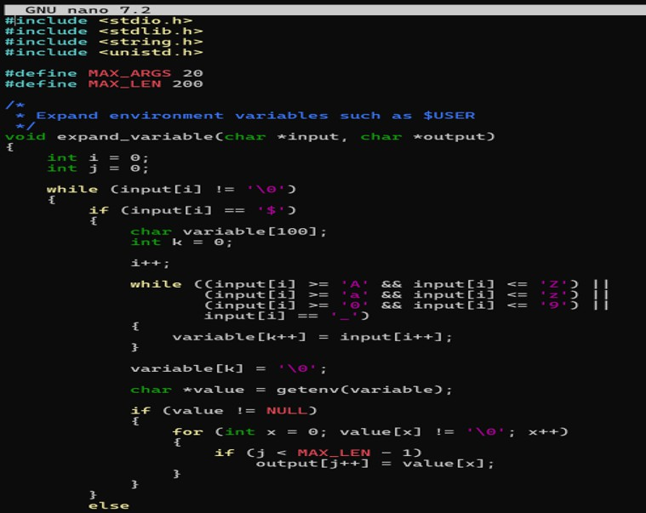
Program :

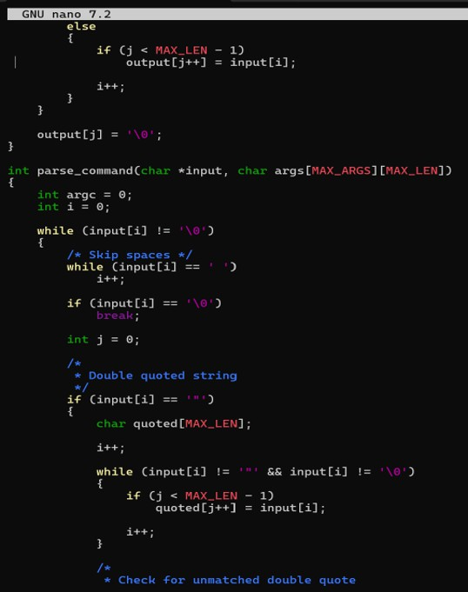

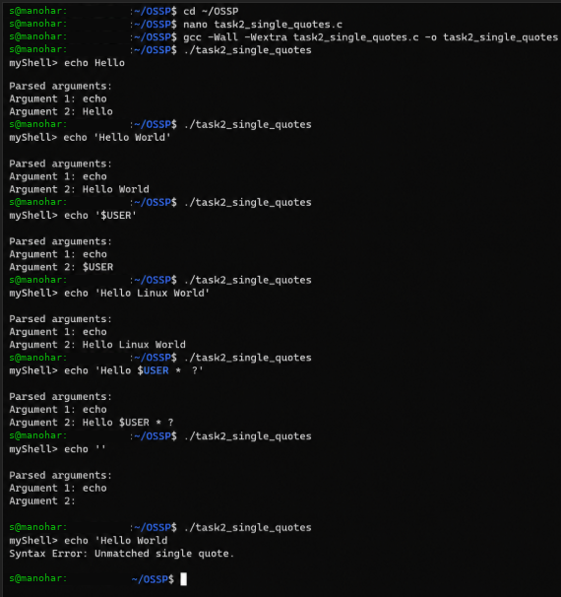Output :

- . To Apply Double Quotes, Preserve Spaces, Allow Variable Expansion, Parse Nested Tokens, Validate Outputs, Test Quoted Commands
Aim :

To implement double quotes in a shell parser so that:

  - Spaces inside double quotes are preserved.
  - Variables such as $USER are expanded.
  - Quoted text is treated as one argument.
  - Nested tokens can be parsed correctly.
  - Unmatched double quotes are detected.
  - Quoted commands can be tested.

Program :
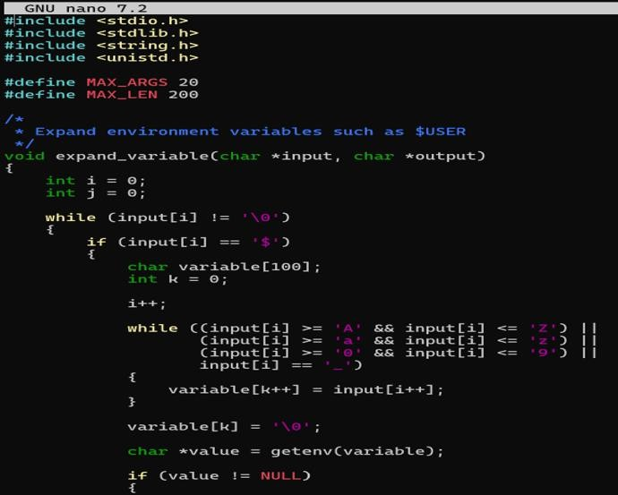

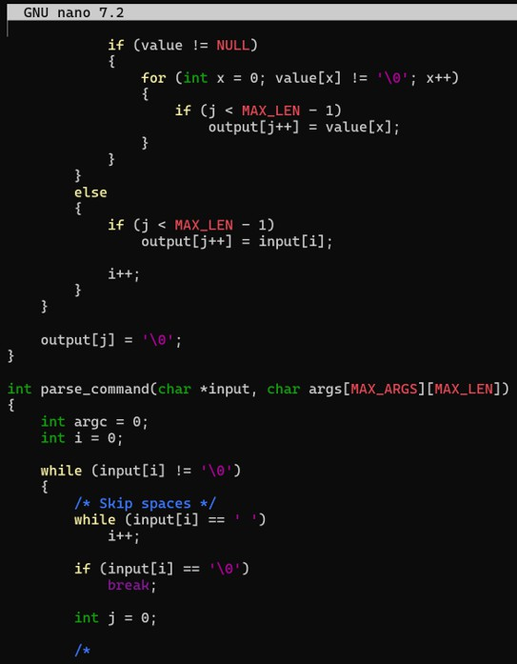

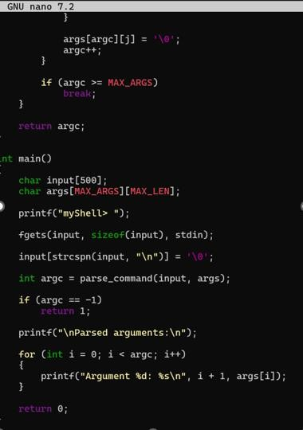

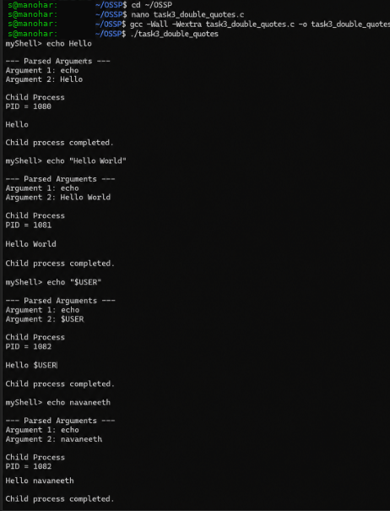Output :

